**LEBANESE AMERICAN UNIVERSITY**

**USAID – HIGHER EDUCATION SCHOLARSHIP PROGRAM**

**HES - Volunteering Program Verification Form**

This form is to be used to document volunteering hours. If a student volunteers for multiple organizations, a separate form must be used for each organization. **This form must be turned in by the 28th of each month, the latest.**

I certify that the scholar Michelle Baalbaky completed a total of 5 hours of service at InnovaThrive.

The hours were completed hours as per the below:

Hours # 2 (date) _2/12 – 6/12_ (initials of supervisor) __A.K.___

Hours # 1 (date) _9/12 – 13/12_ (initials of supervisor) __A.K.___

Hours # 2 date) _16/12 – 20/12 (initials of supervisor) __A.K.___

Hours # 0 date) _23/12 - 27/12 (initials of supervisor) __A.K.___

Brief description of the activities the scholar performed or participated in:

Michelle conducted a research on the following topics:AI in Wildlife Migration Tracking and Conservation  
Definition: Investigating AI’s role in monitoring and protecting wildlife migration routes.  
Technologies:  
  
Drone surveillance powered by AI for tracking species.  
Machine learning for analyzing migration patterns.  
Applications:  
Predicting migration disruptions due to climate change.  
AI-guided policies for creating wildlife corridors.  
Statistics: Reports showing improved accuracy in tracking migration patterns with AI by 40%.  
Advantages:  
Real-time insights for conservation efforts.  
Proactive protection of endangered species.  
Disadvantages:  
Ethical concerns about intrusive monitoring.  
Challenges:  
Balancing human development with conservation needs.  
Future Research:  
AI for cross-border collaboration in wildlife preservation.  
  
Integration with local communities for sustainable conservation.

Written feedback about the scholar’s performance:

Michelle Baalbaky’s research on AI in wildlife conservation was compelling, showcasing AI’s power in tracking and protecting endangered species, while addressing ethical considerations and sustainable practices

Please rate the overall performance of the scholar at your organization:

|  |  |  |  |
| --- | --- | --- | --- |
|  | Mastery (5) | Proficient (3) | Emerging (1) |
| **Problem solver** | X |  |  |
| **Engaged & Committed** | X |  |  |
| **Open-minded & multicultural** | X |  |  |

Signature

& stamp

__________________________

_

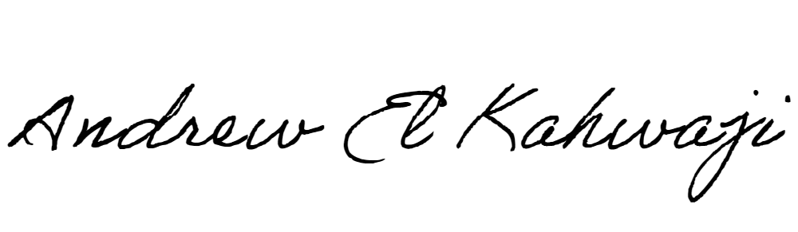

Printed Name _Andrew El Kahwaji_

Date __26/12/2024___

Email __andrew.lifesculptor.coo@gmail.com __

Phone __+961 71 914 378__